**Mike Stoner**

1.     What are the LE roles

2.     1 question on how encryption impacts tables

3.     User criteria as applied to knowledge

4.     HR criteria. when is it used?

5.     LE workshop - suggested steps --

6.     If want hr service to show up on the portal, fill in Record Producer

7.     Client roles > how opened for/subject person values filled in HR Case

8.     Difference between user and hr profile tables

9.     What are common groups of a hr service center

10.  How is delegated developer setup

**11.  What happens when you take hr_admin away from admin**

**Answer: No longer able to view HR Cases and profile information**

**12.  User criteria. What order is it applied (pg192)**

**Answer: cannot contribute, cannot read, can contribute, can read**

**John Lampson**

1. After Matching Rules, what is used to assign cases?

a. Assignment Rules

2. Can Skills be used to assign cases?

a. Yes/True

3. What table does the HR Lifecycle Events Case directly extend?

a. sn_hr_core_case

4. Who can install Content/Data Packs from the Partner Portal? (pick BEST answer)

a. Partners, Customers, and ServiceNow employees

**b.     Partners only**

c.   Customers

d. ServiceNow employees

*5.     What training would you recommend for someone who is new to both SN and HR in SN? (select all that apply)*

*a.     Fulfiller Training*

*b.     HR Fundamentals*

*c.      HR Implementation*

d. *Platform Fundamentals*

6. What are the maturity levels of HR (3 of them)

a. Managed Interactions, Self-Reliance, Automated Services

**b.     Managed Interactions, Self-Reliance, Smart Services (pg 37)**

7. Where do you go to set the default HR E-mail Address?

**a.     HR Administration->Properties** (pg 79)

b. System Properties>Email

8. HR Criteria can be used for

a. Bulk Case Creation

9. How do you skip an Activity?

a. You can't

b. Set on the Activity Trigger

c.   Set on the Activity set condition (pg 24???) (pg 86)

d. **If HR Criteria doesn't apply** (pg 107)

10.  How do you see the translations of a KB article?

a. Translated Versions related list

11.  Which of the following are valid scopes in the HRSD application? (pg78)

**a.     Human Resources Scoped App: Core**

**b.     Human Resources Scoped App: Service Portal**

**c.     Human Resources Scoped App: Lifecycle Events**

**d.     Human Resources Scoped App: Integrations**

e. Human Resources Scoped App: Knowledge

12.  Which of the following can HR Admins do?

a. **Configure most actions for the HR application (pg 230)**

b. Add users to groups [Michel. I think they also can add users to groups since skill_admin contained by sn_hr_core.manager contained by sn_hr_core.admin]

c.   Access HR SLA Definitions

13.  What authenticates information to other systems via endpoints? pg148

a. REST

b. SOAP

c.   **APIs**

d. ODBC

14.  How many Client Role Rule conditions are there OOB?

a. 1

**b. 5**

c.   10

d. X

15.  What role do you need in order to access HR Properties?

a. Admin

**b. HR Admin**

c.   HR Manager

16.  Which of the following appear as options for the steps in HR Guided Setup (pg81)

a. Begin

**b. Get Started**

**c. Skip**

**d. Continue**

17.  What does the Owning Group on an HR Template do?

<https://docs.servicenow.com/bundle/jakarta-hr-service-delivery/page/product/human-resources/concept/c_HRTemplates.html>

a. Assigns cases to that group

b. Approvals for HR Task Templates go to that group

c.   That group can configure the HR Service

**d. They can configure the HR Template**

18.  When is an HR Template applied to an HR case? (pg86)

a. When an HR Service is selected

19.  *What are some common metrics in HR?*

*a. First call resolution*

*b. Time to respond to e-mail/self-service*

*c.   Escalations*

20.  How does information from a case get into a PDF Document Template? (pg.92)

a. Mail merge technology

**b. Pre-configured form fields**

21.  True or **False**, Activities can be used in more than one Activity Set.

**Only one field referencing Activity Set exists on the Activity form**

22.  Activity types are one of the following:

**Fulfiller and Employee are the only choices for Activity Type OOB**

a. HR and Other Department

**b. Fulfiller and Employee**

c.   HR Professional and Employee

23.  If the trigger condition on an Activity Set is date, what else needs to be selected?

a. Activity Type

B. Table something or other

**C. Trigger Table and Trigger field**

24.  When importing Knowledge documents, how is the date set?

a. It isn't

b. Set to the same as the import date

**c.   You can select it**

25.  HR Criteria is used to (select all that apply) (pg106)

**a. Determine what employees see on the portal**

**b. Determines when to trigger an activity in a Lifecycle Event**

**c.   As a filter for creating bulk cases**

d. Control entitlements for Knowledge articles

26.  The User Criteria evaluation order applied for Knowledge bases or articles is:  (pg192)

a. Cannot Contribute>Cannot Read>Can Contribute>Can Read

27.  What options are available in the HR Service Portal (select all that apply) (p127)

**Per OOB configuration**

**a. Branding Editor**

**b. Designer**

**c.   Page Editor**

**d. Widget Editor**

28.  By default, the following information is sent outbound to third-party HR applications (select all that apply) (pg152)

**a. Legal first name and legal last name**

**b. Contact information**

c.   Payroll

**d.      Leave of Absence (LOA) service**

29.  What verifies the accuracy of data transfer from a staging table into the destination table? (pg 160)

a.     Job Tracker

**b.     Logs**

c.      HR Transform Maps

30.  Which of the following are translated based on language? (select all that apply) (pg.185)

**a.     Buttons**

**b.     Menu Options**

**c.      Labels**

**d.     Currencies**

e.     Journal entries

31.  Where can a logged-in user change their language? (pg 184)

**a.     Portal profile**

b.     The language in the User table

c.      At the login screen

32.  If a Knowledge Base has no User Criteria, who can read articles in it?(pg 192)

**a.     Any user with a role**

b.     Although it says users without a role can read but not contribute....

33.  How can you mark a Knowledge article as Featured? (pg193)

**Add an article to the Featured Content related list on the selected knowledge base and provide key words.**

**Pin the article**

[**https://docs.servicenow.com/bundle/jakarta-servicenow-platform/page/product/knowledge-management/task/t_PinAnArticle.html**](https://docs.servicenow.com/bundle/jakarta-servicenow-platform/page/product/knowledge-management/task/t_PinAnArticle.html)

34.  If you give someone Delegated Developer, what else do you need to do so they can develop in the HR scopes? (pg.214)(215)

**a.     Nothing, just walk away.**

b.     Grant them the HR Admin role as well

35.  Which of the following are required to be able to select someone in an HR case? (uses sys_user)

**a.     User records**

b.     HR Profiles

c.      Both

36.  What does encryption do?

a. Text fields and attachments can't be indexed

37.  What role is needed to view the confidential data on the HR Profile? (pg.229)

**a.     sn_hr_core.profile_reader**

**Bryan Harris**

38. ServiceNow uses the _______ to construct SOAP messages (pg 148)

·        **WSDL**

·        CSV file

·        JSON

39. What is the minimum role needed to edit HR integrations? (pg 158)

·        **sn_hr_integrations.admin**

·        sn_hr_admin

·        E

40. What is needed to make an HR service available in the portal?

·        **Record Producer**

·

41. **T**/F - Every table in SN has a number of interfaces that can be made available to third party systems

42. ·     T/**F** - Implementation stories must be logged in the Services Portal (pg.41)

43. ·     T/**F** - A limitation of SN is that HR templates can not be linked to each other

·

44. How many HR templates can be linked together?

**Once ‘Template’ field is selected on a Template record, another Template cannot be selected.**

**·        1**

·        3

·        0

·        Unlimited

·

45. What can be defined through an HR Template?

·        **Tasks**

**·        Approvals**

·        Workflow

·

46. What happens if "If true, ACLs check if the user is being impersonated" is set to yes?

·      Admin cannot impersonate an HR user

·      **Admin impersonating an HR user can not view confidential HR information**(pg.28, 79)

·      Admin impersonating an HR user CAN view confidential information

·

47. What makes sure SN is pulling in the correct HR data from other sources?

·        HR Service Mapping

·        HR Schema Mapping

·        Staging Tables

48. How does SN delegated development enforce scope rules for HR? Select all that apply [Michel page 217 I’m not sure what’s the right answer here]

·        a. Scope validated at run time for every business rule

·        b. Scope validated in script editor

·       **c. Scope warnings are highly visible in editor**

·        d. Something else

·

49. What is the minimum role to edit Lifecycle Events?

·        Three options were sn_hr_core.something

·        Only one option was sn_hr_le.something

sn_hr_le.admin

sn_hr_le.case_reader

sn_hr_le.case_writer

sn_her_le.activity_xxx - TRICK - NO

Page 78, 116

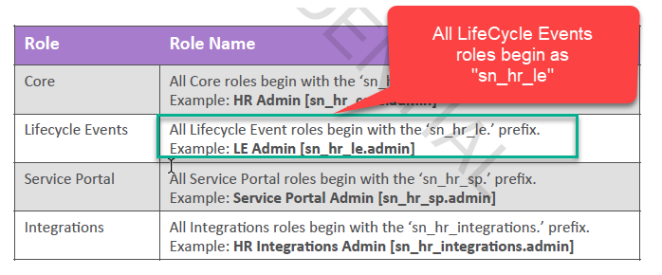

·

50. What role must be removed from System Administrator at go-live so they can't access confidential information?

·        **Sn_hr_core.admin**

·        Hr_agent

·        Admin can always view confidential HR data

Explanation:

HR Implementation Participant Guide Page 228

"A user with the **sn_hr_core.admin** role can also revoke the System Administrator's access to the HR application"

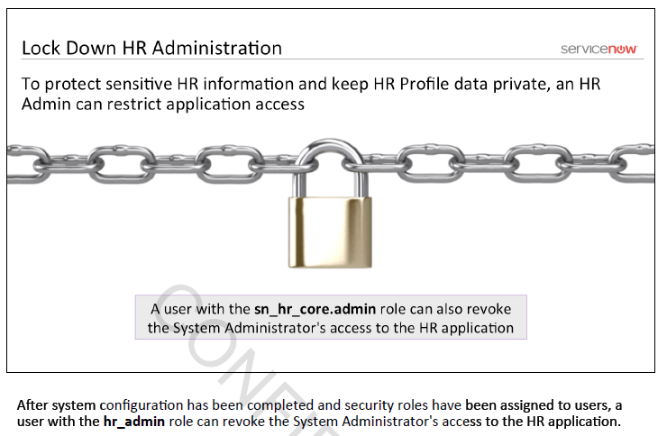

·

51. Which of the following plugins required dependencies for Lifecycle Events plugin? - Alvis

·        HR Integrations [com.sn_hr_integrations]

·       **HR Service Portal [com.sn_hr_service_portal]**  
·        **HR Core [com.sn_hr_core**]  
·        HR Data Migration [com.sn_hr_migration]

**Answer: To enable the Lifecycle Events plugin, it must require HR Core & HR Service Portal**

Source: https://docs.servicenow.com/bundle/jakarta-hr-service-delivery/page/product/human-resources/task/activate-enterprise-onboarding-and-transitions-scoped.html

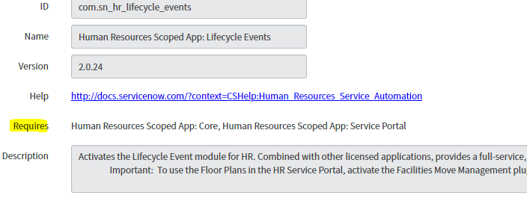

·

52. What must be configured for the HR chat queue to be available? Select all that apply - Carl

·        Assignment group must be defined for HR chat queue - correct (docs)

·        Chat schedule must be applied - correct (docs) otherwise available to all users

·        Plugin Connect Support must be installed (com.glide.connect.support) - correct (docs)

·        Requires role: admin or hr_admin - correct (docs)

·        Must purchase separate license for Connect Support (?? Guess so??)

Source:

See: <https://docs.servicenow.com/bundle/jakarta-hr-service-delivery/page/product/human-resources/concept/chat-for-scoped-hr.html>

From implementation book page 124.

Also see lab 3.4, there is an exercise to configure a HR chat queue. Note the plug in is already switched on.

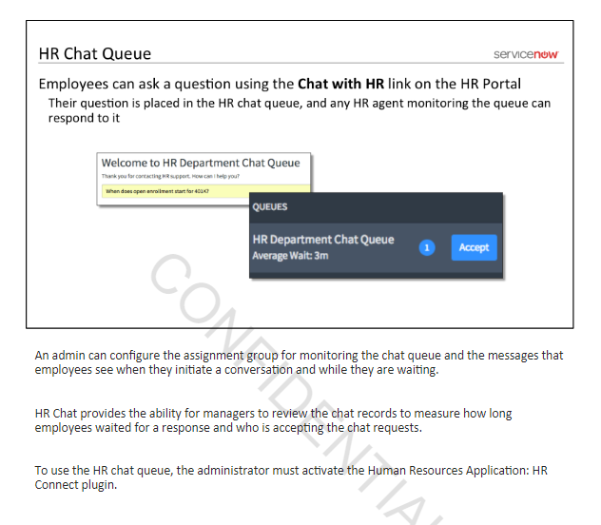

·

53. What role, at a minimum, is typically granted to ALL HR employees? - Cesar

·        HR Basic [sn_hr_core.basic]

Explanation:

HR Fundamentals Participant Guide Page 228

"The HR Basic role is required, at a minimum, for an HR Professional to access HR applications."

·

54. HR Profiles are created for? Select all that apply: - Carl

I cannot find a question like this in the implementation book. I'm wondering whether the question should be: What Employment types are valid within a HR Profile?

·        Full Time Employees - correct

·        New Hires – correct? MH I can’t find this option although

·        Contingent - correct

·        Beneficiaries - no

·        Part Time Employee - correct (added)

·        Temporary Employee - correct (added)

·        Contractor - correct (added)

Explanation:

·

From valid choice list on field employment_type:

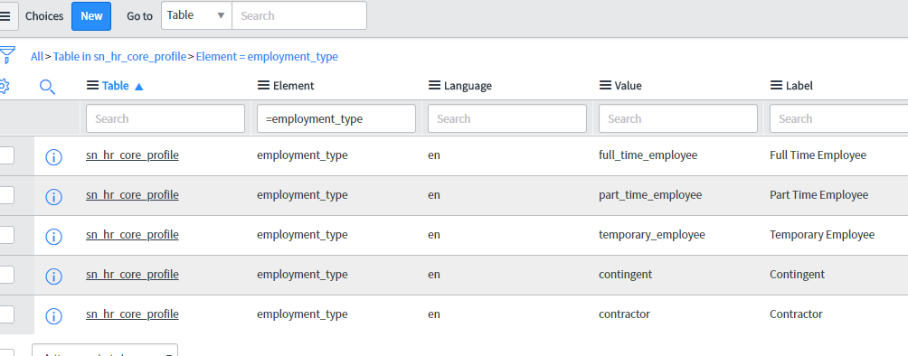

Searched fundamental and implementation books and docs site, could not find question

54. HR Document Template revisions are stored as/in…? - Alvis

·        Managed Documents?

·

55. E-signatures on HR PDF documents are stored as? - Lawrence

·       **An image on the PDF file**

·        An attachment

·        Electronic delivery(?)

Explanation

[p. 20]

[p. 168]

·

56. Who can edit an HR Document Template - Lynne

·        Owning Group -

·        Owner of managed document

Owning Group

SN Docs: https://docs.servicenow.com/bundle/jakarta-hr-service-delivery/page/product/human-resources/task/t_AddHRPDFDocumentTemplate.html

Role required to create an HR Document Template: sn_hr_core.manager and sn_hr_le.admin

·

57. Where are HR templates associated with an HR Service? - Lynne

·        On the HR template form (?)

·        On the HR Service

·        On the Lifecycle event (?)

·        On the activity set

On the HR Service

58. Select the 4 valid HR scopes from a list of 6 options – Alvis

**Answer:** HR Core, HR Service Portal, HR Integrations, HR Lifecycle Events  
Source: HR Implementation PDF – Page 78  
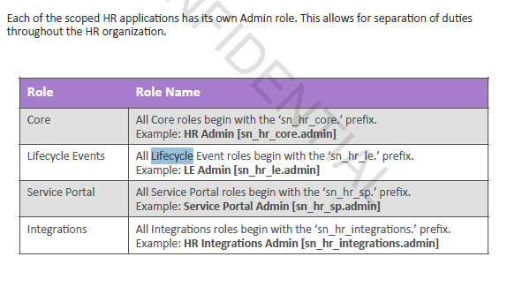

·

59. Why are some tasks locked on HR Guided Setup? - Carl

·        A plugin needs to be installed to work on those tasks - correct

·        Other tasks need to be completed first

·

Source: Implementation book page 82

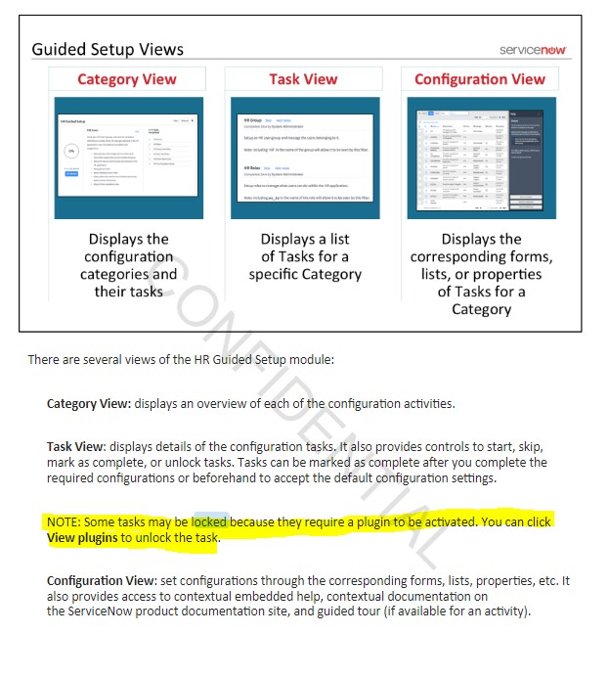

60. What does a Data Pack contain? - Cesar

·        Stories to start an engagement

Explanation:

HR Implementation Participant Guide Page 42

"The HR Data Pack contains a pre-defined selection of HR stories and project tasks"

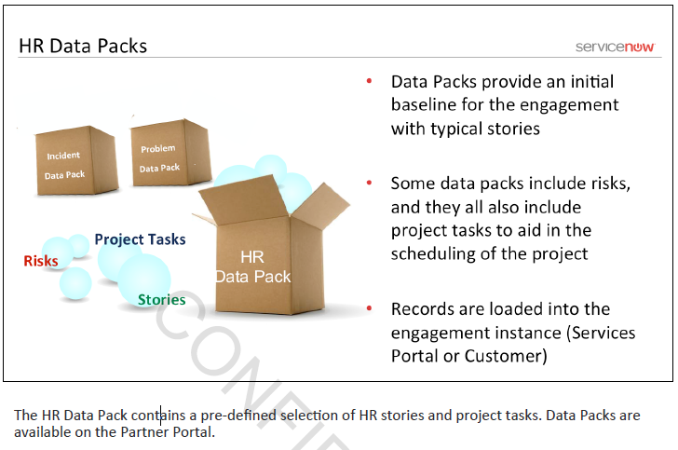

·

61. Where do you get Data Packs? - Derek (pg 42)

·       **Partners get them on the Partner Portal**,

SN Employees get them on the Services Portal

·

62. What table is considered the core for all HR Cases? - Mark

·        **HR Case [sn_hr_core_case]** (page 70 of Implementation Guide)

·

63. If an activity set is triggered based on a date, what field is required? - Jamie

·        Trigger table and trigger field

|  |  |
| --- | --- |
| **Trigger table** | Displays when Date is selected as the **Trigger type**. Select a table that determines the date field that can be used as a trigger.   * Case tables: From parent life-cycle event case. * HR profile: Profile of subject person from parent life-cycle event case. |
| **Trigger field** | Displays when Date is selected as the **Trigger type**. The date fields that display depend on the table selected in the **Trigger table** field.  Select the type of date to trigger the activity set.  Source: https://docs.servicenow.com/bundle/kingston-hr-service-delivery/page/product/human-resources/task/ManageActivitySets.html |

·

64. As of Jarkarta, the HR application is called?

**Human Resources Service Delivery (HRSD)**

HR Soufflé Delivery

Home Run Swinging Dude

HR Service Management

Late for Dinner

You can call me Al

**[Page 13]**

·

65. Access to view KB Articles is based on - Lynne

·        Can/Cannot Read criteria

·

66. If translation is enabled, are free form text fields translated? - Rick

·        Yes if the plugin is installed

·        **Journal entry fields are not translated**

·        Journal entry fields are translated

HR Implementation- Participants Guide (Page 185)

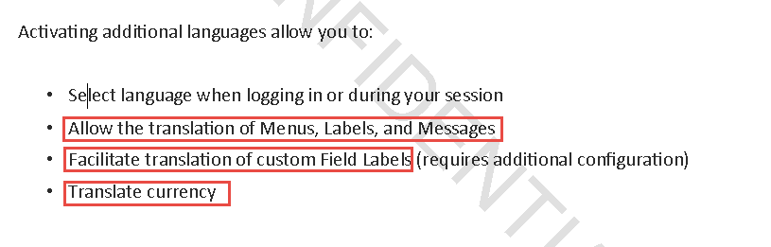

·

67. If translation is enabled, what is translated on the Portal? Select all that apply: - (page 185) - Bryan

·       **Buttons**

·        **Labels**

·        Widgets

·        **Menu options**

·        **User-facing system messages**

68. When are assignment rules used? - Alvis

·        **When no assignment group is defined**

·     **When the HR Service doesn't have a template defined**

·        When the lifecycle activity doesn't have a template defined [Michel: I think this also applies.]

· Source: HR Implementation PDF pg 88  
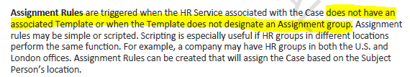

69. T/F escalation rules can be defined for the HR scope - Carl

True – See <https://docs.servicenow.com/bundle/jakarta-hr-service-delivery/page/product/human-resources/task/t_CreateOrModifyEscalationRules.html>

·

70. T/F ServiceNow uses HTTPS so data is always TLS encrypted in transit – Carl - Cesar

**Answer**: False

You need to set property glide.outbound.sslv3.disabled to true to force outbound connections to use TLS rather than SSL

See: <https://docs.servicenow.com/bundle/jakarta-platform-administration/page/administer/security/reference/r_GeneralSecuritySettings.html>

·

71. What options are available on a Knowledge Base? - Derek (pg 194)

·        **Disable suggesting**

**·        Disable Commenting**

**·        Disable Category Editing**

·        And one wrong answer

·

72. Common HR Service Groups? Select all that apply: - Mark

**·**Payroll - Yes

·        IT Support

·        Compensation Questions

·        Leave of Absence Questions

·        HRIS Maintenance

·        One more option

·

73. What method can be invoked to run Matching Rules in the matchingRuleProcessor class? - Mark

a. ProcessAndGetCandidates

·

74. What role at a minimum is required to assign HR scope roles? - Jamie Cagod

b. Hr_admin (correct **P214**)

c.   Hr_manager

Only the HR Administrator [sn_hr_core.admin] can assign scoped HR roles. These roles can be assigned to inactive users to create HR cases for new hires and alumni.

**Source:** https://docs.servicenow.com/bundle/kingston-hr-service-delivery/page/product/human-resources/concept/c_ManageRoles.html

**Wei Lin**

**True/False (2 questions):**

75. A limitation of HR Templates is that one HR Template cannot call another HR Template - Lawrence

False; True

76. The HR Manager [sn_hr_core.manager] role contains HR Basic [hr_basic] role - Lynne

False; True (hr_basic is from legacy non-scoped version))

**Multi-Select (Select all that apply - 14 questions):**

77. Choices for HR Service Fulfillment Type [sn_hr_core_service.fulfillment_type] - Rick

Manual, Service Activity, Workflow, Lifecycle Event, Advanced

78. Choices for Lifecycle Event activity type [sn_hr_le_activity.activity_type]: - Bryan Harris

**Employee**; **Fulfiller**; Approval; Notification (Employee and Fulfiller in Jakarta – Approval and Notification added in Kingston. Verified in dev instance and ServiceNow Docs)

79. HR Shared Service Centers Processes may include: Alvis

Payroll Administration, Compensation Administration, Leave of absence (LoA) Administration, HRIS maintenance, IT Help Desk

**Answer:** All except IT Help Desk, IT Help Desk is part of incident/ITSM and is not a HR Service

Source: HR Implementation PDF page 70 [Michel: I don’t agree that HRIS maintenance is one of the right answers. HR system maintenance is not part of the HR service offering]  
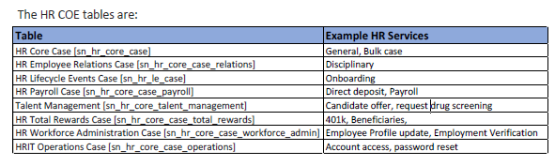

80. Why should HR Admin role be removed from Admin? What can Admin do after this? What can HR Admin do without Admin role? - Carl

HR admin can do which of the following without Admin role?

81. What does Encryption process do? - Cesar

**It requires an admin to grant an Encryption context to a role**

It prevents database access and indexing of text fields and attachments

It prevents users from adding encrypted fields to a filter [Michel: all three p220]

Explanation:

HR Implementation Participant Guide Page 220

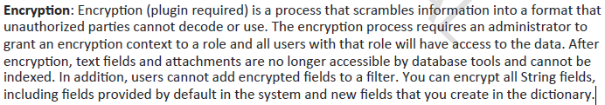

82. Localization settings control what? - Derek (pg183)

translation, currency, and locale settings

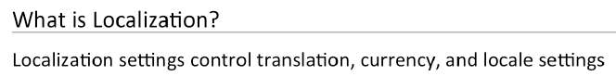

83. HRSP - Config. Options: - Mark

Designer; Page editor, Branding editor; Widget editor

84. HRSP - What gets translated? - Jamie Cagod

Menu options, Buttons, Labels, Widgets

Same as Q67

85. Primary security focus for HRSD: - Lawrence

Roles & groups; platform security [p212]

86. HR profile table vs. user table: - Lynne

HR profile table can show personal/confidential/sensitive data of each employee

HR profile table can show employee HR details

87. HR criteria vs User criteria – Rick

HR Implementation- Participants Guide (Page 106, 107)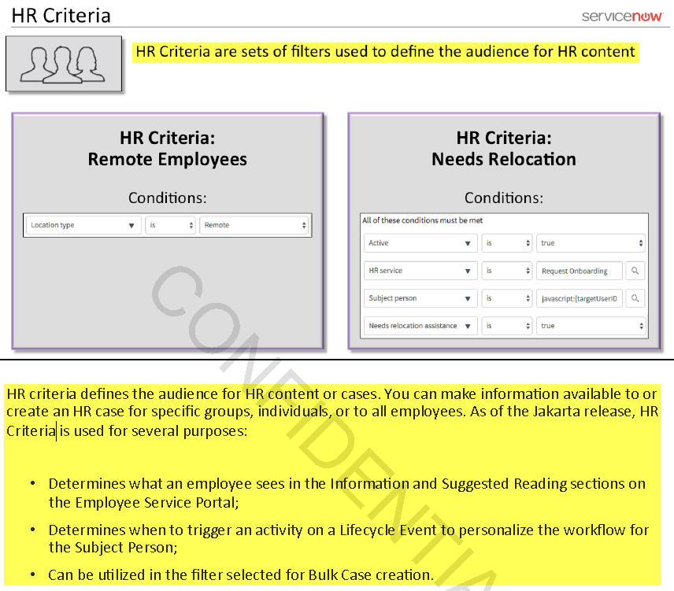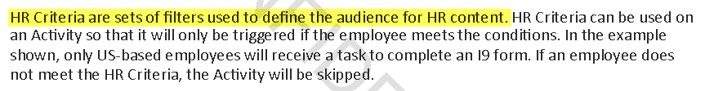

HR Implementation- Participants Guide (Page 191)

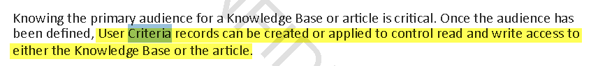

HR Implementation- Participants Guide (Page 192)



88. HR task type include the following: (page 86) - Bryan Harris

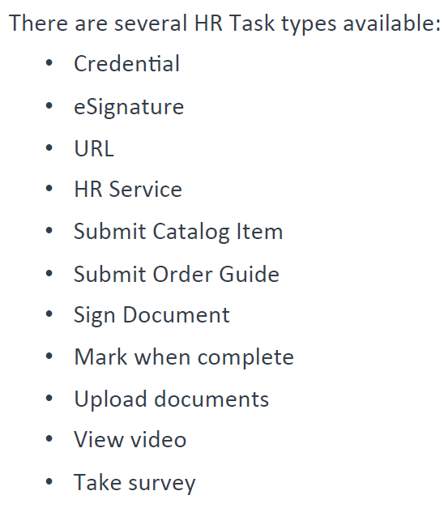

89. How to make HR task optional? -Alvis

**Answer: In the HR template of the HR Task, there is an Optional (T/F) field which will make the HR task optional**

Source: https://docs.servicenow.com/bundle/jakarta-hr-service-delivery/page/product/human-resources/concept/c_HRTemplates.html

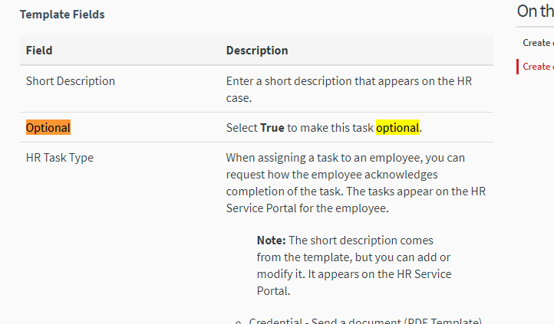

**Single-Select (Multiple Choice - 44 questions, I did not capture all 44):**

90. Diff. among the 4 levels of configuration complexity - Carl

Nominal

Low

Major

Drastic

[Michel: this can found in the CSM book SN-CSMIMPL-J011 page 95]

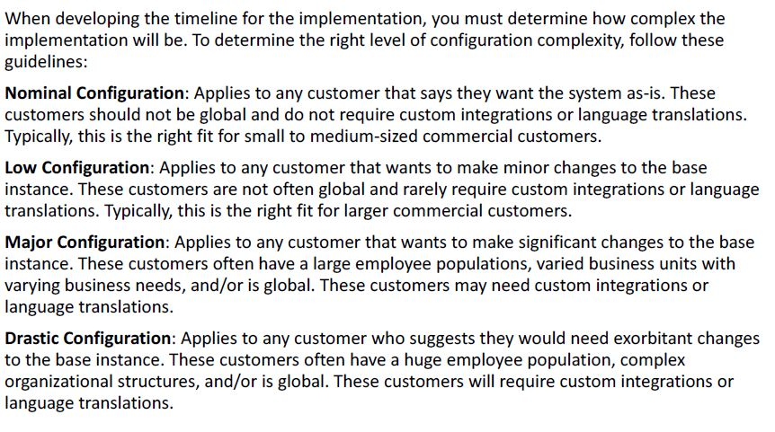

91. When the scheduled sync job runs, data on the HRSM external interface ______ to the third party system - Cesar

**pushes**, pulls, stages, imports

Explanation:

HR Implementation Participant Guide Page 157 & 164



92. Which field allows every application to define its private or public API? - Derek

Accessible to; Accessible from; Private API; Public API [Accessible from p217]

93. Guided setup: why are some tasks locked in task view? - Mark

waiting for other tasks to complete [Michel this is wrong answer. They require plugin to be enabled. P82]

94. Why do you need HR outbound schema mappings? – Jamie

Note that the Mandatory fields are established based on the HR Outbound Schema mappings

95. Who can generate PDC doc. Lawrence

HR professionals only; Assign to user only

96. Who can access Doc Revision? -Lynne

Owning group only

97. How many user criteria can you put on a single KB article? -Rick

Four

Cannot Contribute

Cannot Read

Can Contribute

Can Read

HR Implementation- Participants Guide (Page 192)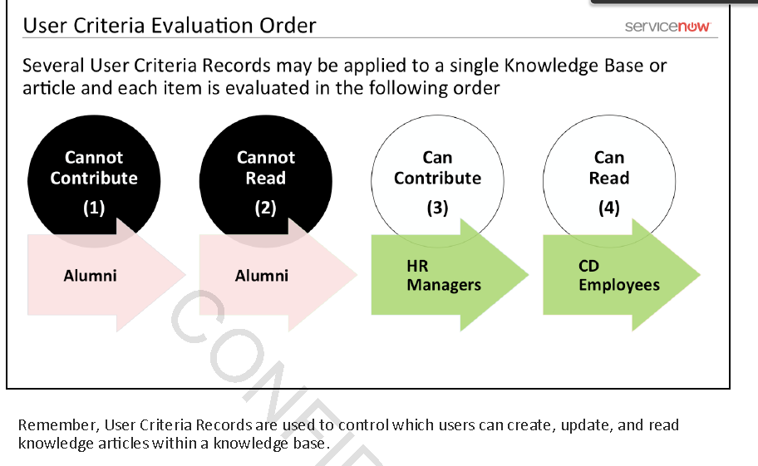

One

98. Alumni means? - Bryan Harris

An employee who has left the employer

99. What is required after Delegated developer role is assigned? Who can do it? - Alvis

Activate specific permissions via sys_store_app.list

**Answer: Not sure what the question is asking but only Admin /w hr_admin role can set delegated developer role via sys_store_app.list**

Source: <https://docs.servicenow.com/bundle/jakarta-hr-service-delivery/page/product/human-resources/task/t_HRAdminRoles.html>

100. What user criteria is required to make “importing Knowledge documents” visible? - Carl

Can Contribute – correct

https://docs.servicenow.com/bundle/istanbul-servicenow-platform/page/product/knowledge-management/task/t_ImportADocument.html

Source – implementation book page 192

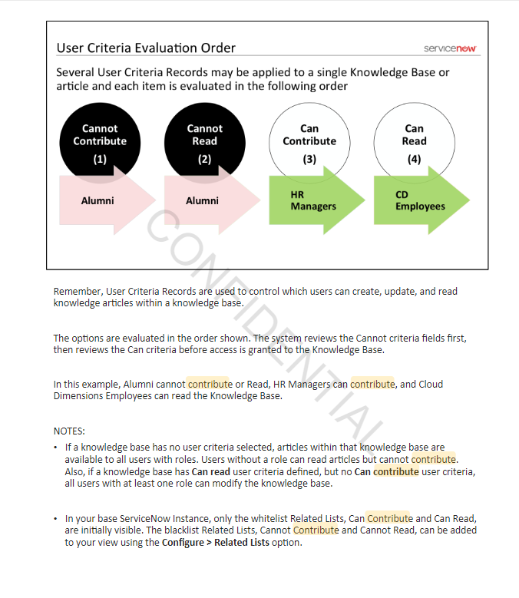

101. What are e-signatures - Cesar

**Answer**: E-signatures are an image of the signature placed on a document to represent and acknowledgement or approval

Explanation:

HR Implementation Participant Guide Page 20

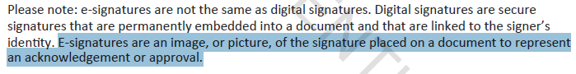

102. HR Task types available (pg 86) - Derek

Credential,eSignature,URL,HR Service,Submit Catalog items ,Submit Order Guide,Sign,Document ,Mark when complete,Upload document,View Video,Take Survey

103. HR migration scope from global to scoped app (pg 179) - Mark

104. In the base ServiceNow instance configuration, e-signature - Michel

a. is Legally binding

b. just an acknowledgement

Answer: p168: just an acknowledgement. DocuSign app is a digital signature provider that can provide this.

105. Base ServiceNow instance supports DocuSign

a. No

b. Yes but (something to do with the direction of sync, inbound or outbound)

Answer: p168: No. Admin has to install DocuSign update set to get the app, so it’s not available OOB.